H.T No
Regulations:
A18

Sreenidhi Institute of Science and Technology
(An Autonomous Institution)
Code No:7KC86 Date: 01-Sept-2021 (FN)

B.Tech III-Year II- Semester External Examination, Aug/Sept - 2021 (Regular)
FOUNDATION ANALYSIS AND DESIGN (CIVIL)

Time: 3 Hours Max.Marks:70

Note: a) No additional answer sheets will be provided.
b) All sub-parts of a question must be answered at one place only, otherwise it will not be valued.
c) Missing data can be assumed suitably.

ANSWER ANY 5 OUT OF 8 QUESTIONS. EACH QUESTION CARRIES 14 MARKS.

Bloom's Cognitive Levels of Learning (BCLL)

Remember | L1 | Apply | L3 | Evaluate | L5
Understand | L2 | Analyze | L4 | Create | L6

 |  |  | BCLL | CO(s) | Marks
1. | a) | Explain SPT test in detail. | L2 | CO1 | [7M]
 | b) | Discuss with neat sketches any two boring methods used in subsoil exploration? | L1 | CO1 | [7M]
2. | a) | How does Rankine’s approach differ from Coulombs approach in the estimation of active earth pressure. | L2 | CO2 | [7M]
 | b) | Determine the coulomb active force on the retaining wall shown below. Ɣ = 17.5 kN/m³, Φ’ = 30⁰, ᵝ = 75⁰  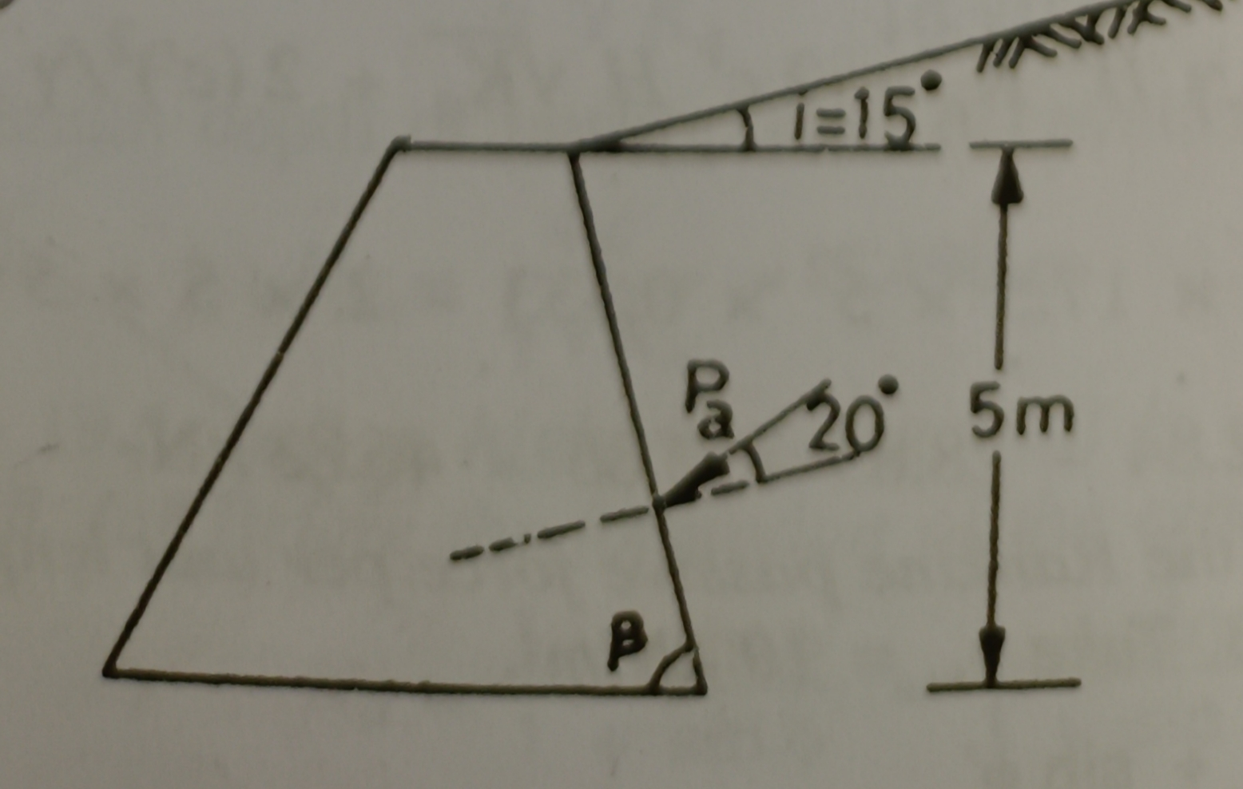 | L5 | CO2 | [7M]
3. | a) | Describe the procedure of determining the safe bearing capacity based on standard penetration test. | L2 | CO3 | [7M]
 | b) | Discuss the effect of shape of footing on the bearing capacity of foundation soil. Differentiate between safe and allowable bearing pressure. | L2 | CO3 | [7M]
4. | a) | Write a detailed note on settlement of foundations | L2 | CO4 | [7M]
 | b) | What are the different causes and measures to reduce settlement of shallow foundation? | L2 | CO4 | [7M]
5. | a) | How will you estimate the load carrying capacity of a pile in cohesionless soil and cohesive soil. | L2 | CO5 | [7M]
 | b) | A concrete pile 30 cm diameter, is driven into a medium dense sand ( Φ = 35⁰, Ɣ = 21 kN/m³, K = 1.0, tanδ = 0.70) for a depth of 8m. estimate the safe load, taking factor of safety of 2.50 & N_{q} = 60. | L5 | CO5 | [7M]
6. | a) | Discuss briefly about sinking of wells. | L2 | CO6 | [7M]
 | b) | A circular well of 6 m external diameter and 4 m internal diameter is embedded to a depth of 15 m below the maximum scour level in a sandy soil deposit. The well is subjected to a horizontal force of 800kN acting at a height of 8 m above scour level. Determine the allowable total equivalent resisting force due to earth pressure, assuming i) the rotation is about a point above the base ii) the rotation is at the base. Take Ɣ_{sat} = 20 kN/m³, Φ = 30⁰ . Factor of safety for passive resistance = 2.0. Use terzaghi’s analysis. | L5 | CO6 | [7M]
7. | a) | Describe with a neat sketch ‘split spoon sampler’ | L1 | CO1 | [5M]
 | b) | Write the assumptions of coulomb’s wedge theory. | L1 | CO2 | [5M]
 | c) | How do you ascertain whether a foundation soil is likely to fail in local shear or in general shear? | L4 | CO3 | [4M]
8. | a) | A rectangular footing 3 m x 2 m size, exerts a pressure of 100 kN/m² on a cohesive soil (E = 5*10⁴ kN/m² and μ = 0.5. Determine the immediate settlement at the center, assuming the footing to be flexible. | L5 | CO4 | [5M]
 | b) | A 30 cm diameter concrete pile is driven into a homogenous consolidated clay deposit (c_{u} = 40kN/m², α = 0.7. If the embedded length is 10 m, estimate the safe load (F.S. = 2.5, N_{c} = 9.0) | L5 | CO5 | [5M]
 | c) | List out the different types of caissons. Explain each. | L1 | CO6 | [4M]

-- 00 -- 00 –

